***PAAREES PERFUMES***

***DAVIDOFF***

***FOR WOMEN***

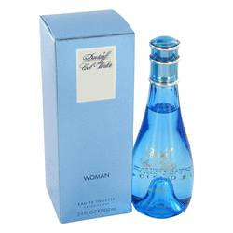

# *Cool Water*

***Description:***

Cool Water by Davidoff Perfume. Infuse your presence with the exotic aromas of Cool Water, and create a memorable, unmistakable you. Introduced in 1996 by Davidoff, this fragrance reveals itself gradually in surprising and enticing layers of scent. Refreshing aromas of citrus, pineapple and honeydew melon mix with deep, exotic hints of quince and rich, tropical lotus notes. Created for active women who know how to preserve their delicate sense of femininity, Cool Water is a noticeable yet well-tempered fragrance, recommended for all-day wear.